

**Bootstrap**

**Submitted By:**

**Shaikh Sameer**

# What is Bootstrap?

* Bootstrap is the most popular framework for quickly styling your website.
* Bootstrap lets us skip writing CSS and focus instead on HTML.

# What is Bootstrap?

**CSS**

* Grid system
* Typograph
* Forms
* Buttons
* Responsive utilities

**Components**

* Glyphicons
* Navbar
* Pagination
* Thumbnails

# What is Bootstrap?





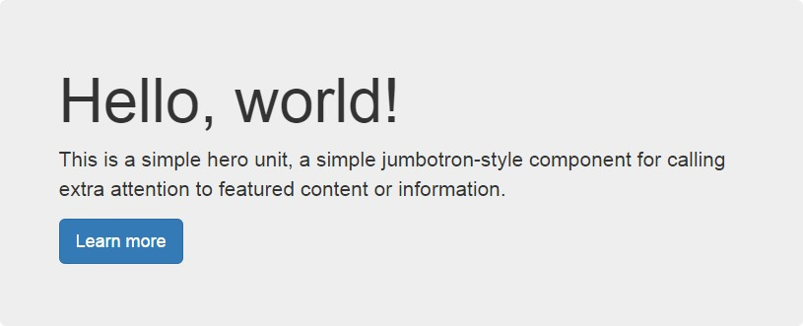

Using Bootstrap

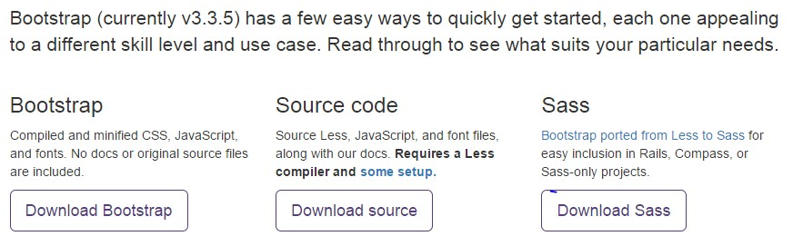

Using Bootstrap

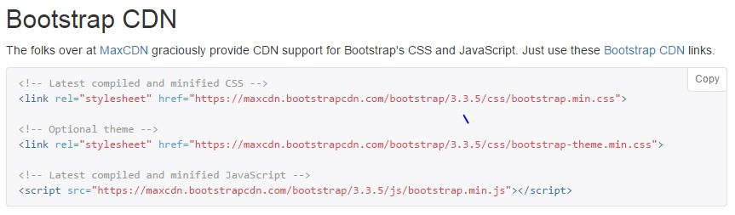

Mobile Friendly

Bootstrap 3 is mobile friendly by default. Responsive to screen size (assignment 1) Touch screen zooming

Add following to your <head> to enable touch zooming.



width=device-width: sets width of page to screen width of the device

initial-scale=1: sets initial zoom level when the page is first loaded

# .Container

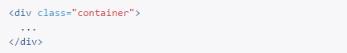

Responsively add margins, center, and wrap your content.

# .Container

Example

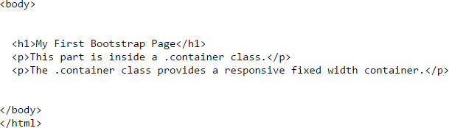

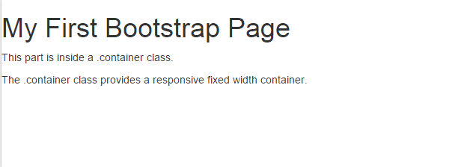

# .Container

Example

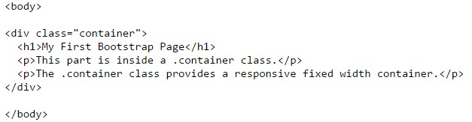

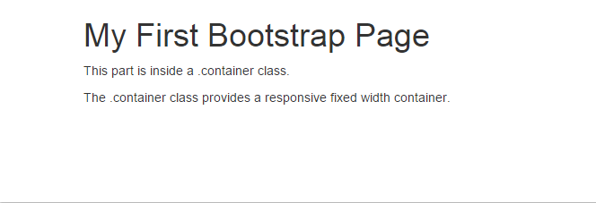

margin

margin

# Grid System

Bootstrap divides a page into a grid of 12 columns and multiple rows for easier positioning of elements.

Grid system is responsive and columns will rearrange automatically depending on the screen size.

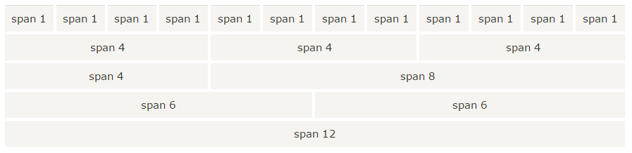

# Grid System

Grid System - Basics

Place columns inside

<div class="row"></div>

for each row.

Set each column width using class prefixes:

.col-xs-*, .col-sm-*, .col-md-*, .col-lg-*

# Example

**Create a row of columns of width 3, 4, and 5.**

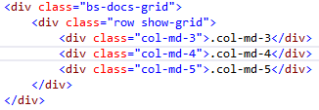



Grid System - Multiple Devices

Sometimes columns are stacked vertically on smaller screens

Use col-xs-*, col-sm-*, col-md-* together to set different column widths for different screen sizes

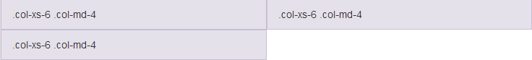

# Example

**Allow 2 columns in a row for mobile, 3 for desktop**

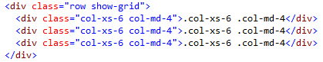

On Desktop: On Mobile:

Grid System – Column Resets

**Sometimes at breakpoints, columns may be aligned in wrong places.**

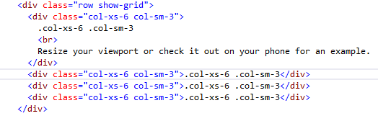

Problem: Correct Output:

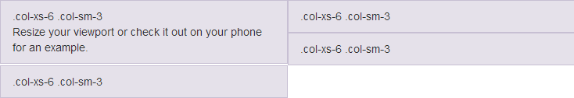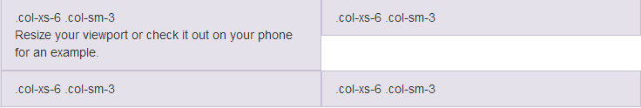

Grid System – Column Resets

**Fix**



.clearfix clears float CSS attribute

visible-xs is one of many responsive utilities

clearfix is applied to only mobile devices (visible-xs)

# Grid System – Column Resets

**Fix**

**Go to next line**

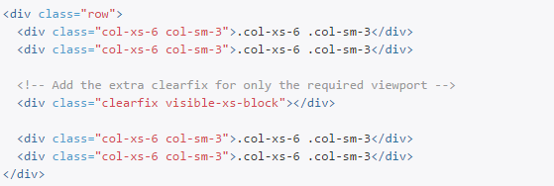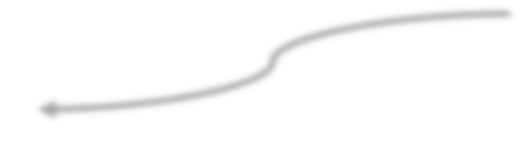

# Responsive utilities

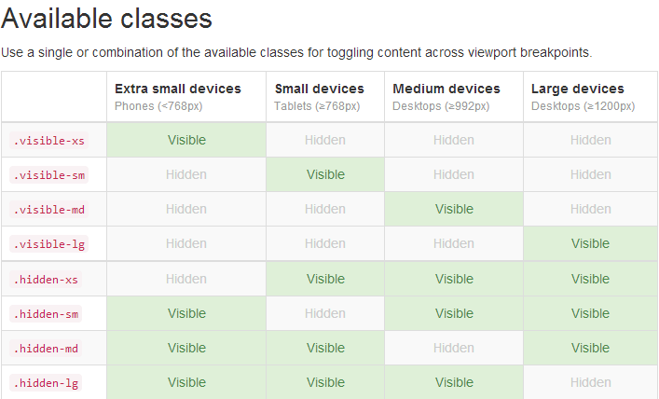

Grid System - Offsetting

col-xs-offset-* col-sm-offset-* col-md-offset-* col-lg-offset-*

# Example





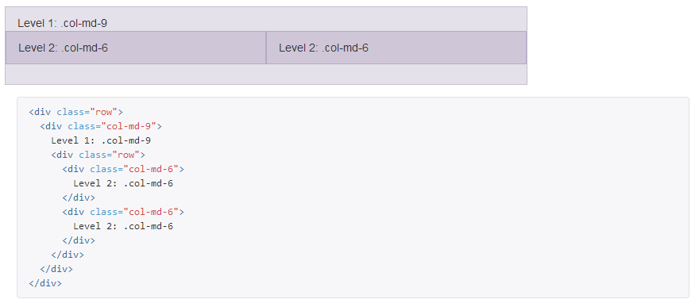Grid System – Nested columns

**Nested columns add up to its parent or less**

Typography - Headings

Supports <h1> to <h6>, same as HTML

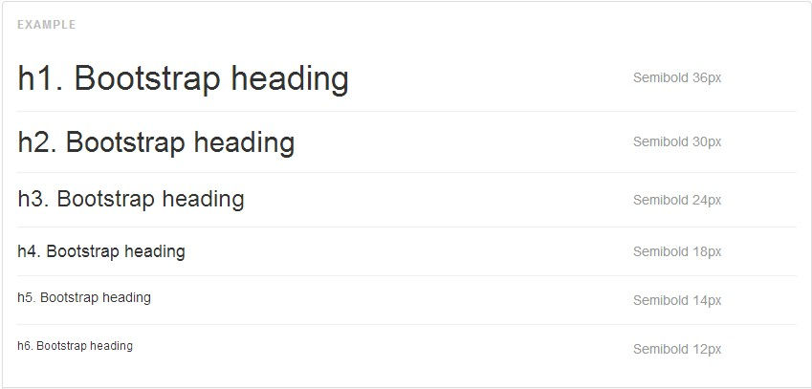

# Typography - Alignment

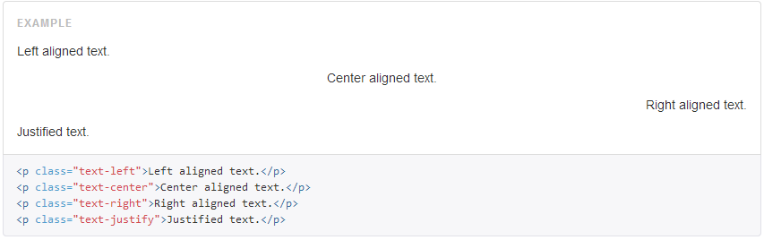

Typography – Addresses

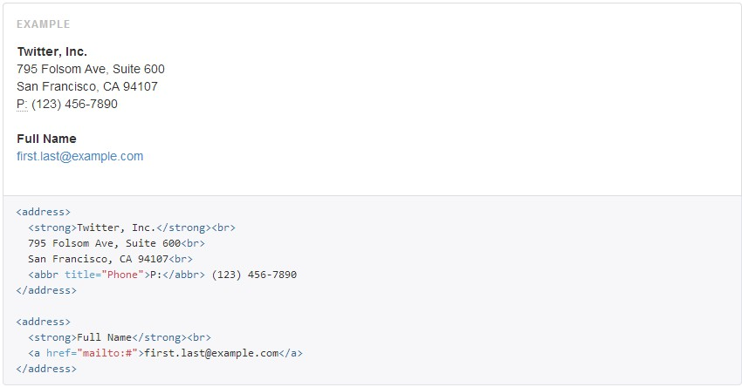

**append <br> to preserve formatting**

Typography - Description

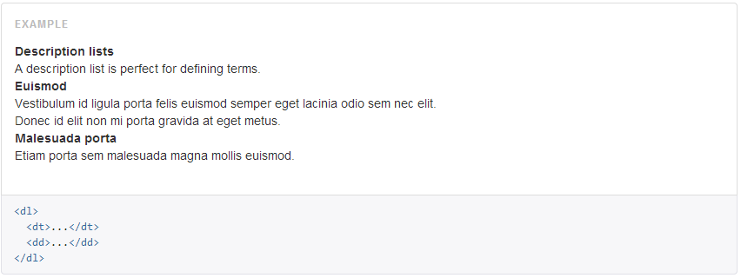

Glyphicons

Bootstrap comes with 200 icons to use, named “glyphicons”

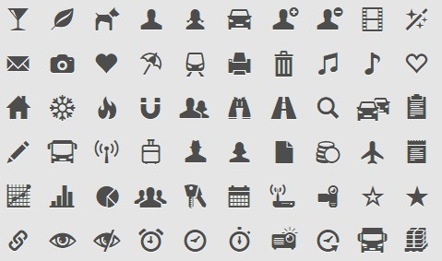

# Glyphicon Syntax

Syntax



Examples



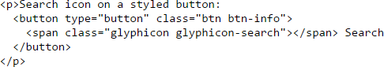

# Resizing Glyphicons

Glyphicons are text!!!

To resize glyphicons, simply increase its font size in CSS!

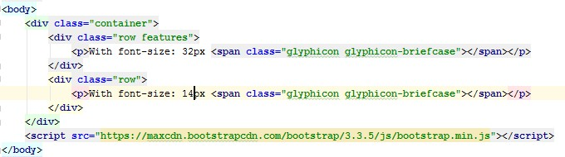 Example

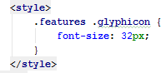

Output

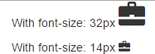

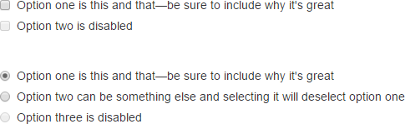

# Forms

Automatically applies some global styling with Bootstrap.

Examples

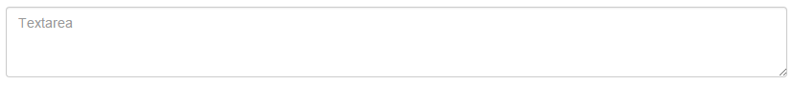

# Forms

Layouts supported by Bootstrap

Vertical Form

Horizontal Form

Inline Form

Tips on using forms with Bootstrap

<form role=“form”> *Improves accessibility*

<div class=“form-group”> *Improves spacing of form elements*

.form-control *Give width of 100% to text form elements*

# Forms – Vertical Layout

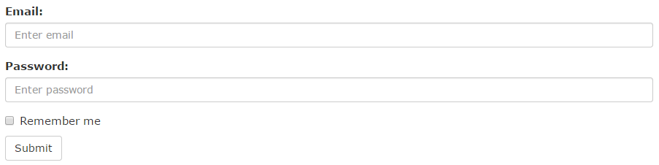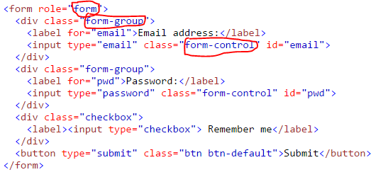

Forms – Horizontal Layout

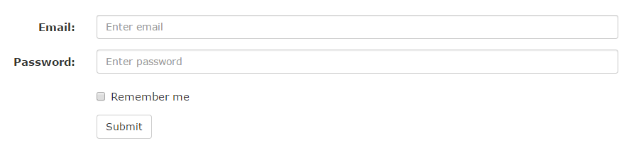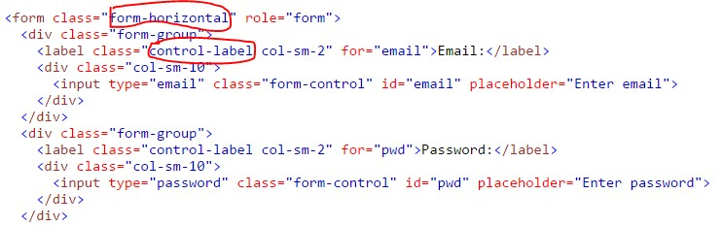

Forms – Inline Layout



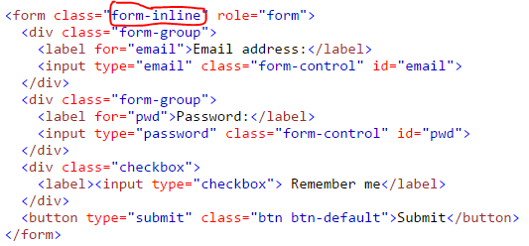

Forms - Controls

Supports HTML form elements

<input>

<textarea>

<input type=“checkbox”>

<input type=“radio”>

<select>

…

# Forms – Validation states

Bootstrap allows you to give validation status to your form elements.

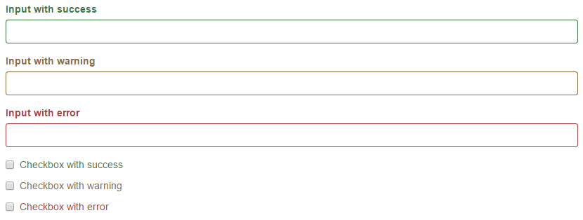 Bootstrap supports

.has-warning

.has-error

.has-success

Example

# Validation States - Input

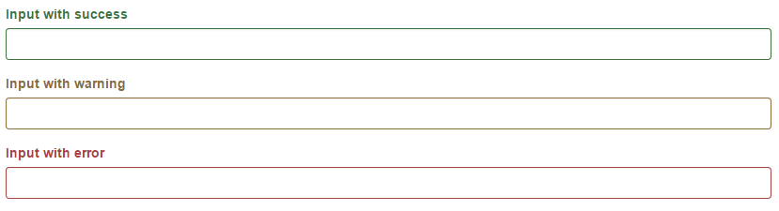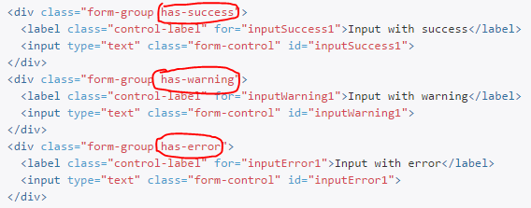

Forms – Validation states with icons

To add feedback icons

1. add has-feedback class to parent
2. insert <span> specifying glyphicon for the control’s feedback

## <span class="glyphicon glyphicon-ok form-control-feedback"></span>

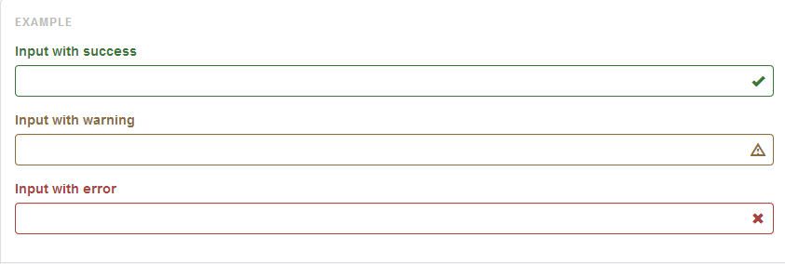

Validation states with Icons



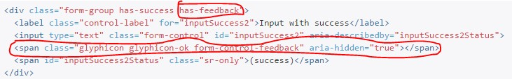

Pagination

You can use Bootstrap to divide your website into pages.

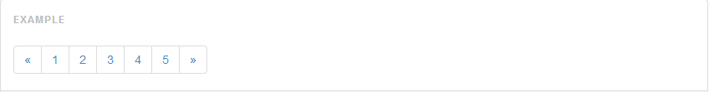

Simply add pagination class to ul element. Each page is a list of href element.

## <ul class="pagination">

e.g. <li><a href="#">1</a></li>

Use pagination-lg or pagination-sm to size page button sizes

# Example - Pagination



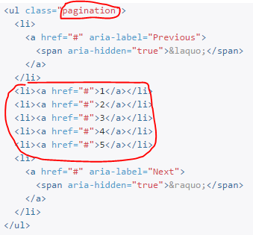

Pager

Simpler version with **“Previous”** or “**Next”** buttons

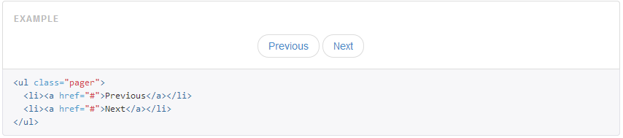

You can also align buttons using .previous and .next

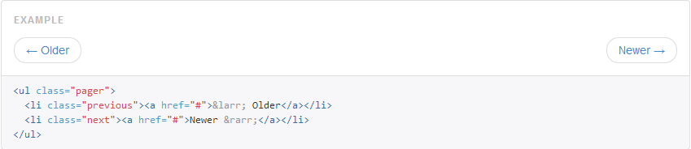

# Navigation & Navigation Bars

Navigation (nav)

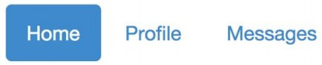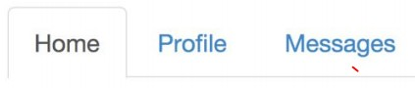

Navigation Bar (navbar)



# Navigation (nav)

Use unordered list and give .nav class attribute.

Example

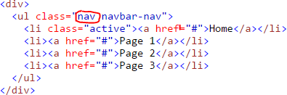



Makes navigation inline

# .nav Modifiers

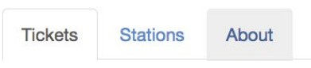



Right aligned

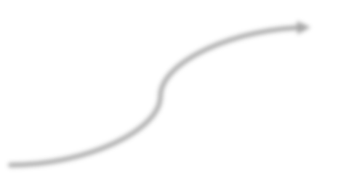

# Navigation Bar (.navbar)

Creates a visible bar with navigation elements.

Example

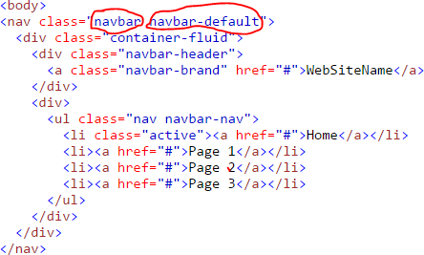



# .navbar Modifiers





**and others …**

References

* <https://www.youtube.com/watch?v=-UEMWJjBXww>
* <https://www.youtube.com/watch?v=frRyAlz82Ok>
* <https://getbootstrap.com/docs>